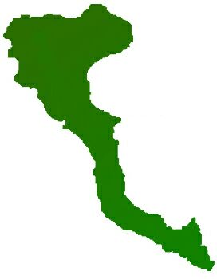

|  |  |
| --- | --- |
| **Team: 3-D Protocol number: 5** | |
|  | |
| **Author: Pedro Arenas** | **Date**: 12.01.2021 |
| **Place:** MS Teams at 11.15 hrs |
| **Participants:**  - Adnan, Muhammad  - Arenas, Pedro  - Shahid, Arsalan  - Ur Rehman, Mutee | |

| **Protocol of the meeting of 01 December 2020** | | |
| --- | --- | --- |
| **Topic** | **Results** | **Time** |
| Project Decisions | Mr. Shahid will be team leader until next change | 1 min |
| Task State | Mr. Arenas already finished and documented the CMS (Content management system) | 5 min |
|  | Mr. Shahid is still working on searching functionality, planned to end this week. | 5 min |
|  | Mr. Adnan is still working on front-end tasks, current state:   * Configuring the service methods to call API methods. (_service/movies) * Creating Models * Create service methods to consume TV data. * Set Carosal on the home-page * Working on Homepage (Set html and data for TrendingNow, Most Voted, PopularShows and Upcoming Movies) | 10 min |
|  | Mr. Mutee, will test and fix the HTML and Javascript issues related to the front-end application. |  |
| Next Tasks | Mr. Arenas will create final report schema and add CMS documentation to it | 1 min |
|  | Mr. Arenas will start working on users control and authentication | 1 min |
| Other Topics | Recap about already done tasks:   * As agreed, Mr. Adnan has created and integrated the HTML Template into Angular Application. Added libraries. * Mr. Adnan also created the structure of the application, which includes, components (header, footer etc). Service layer are already done also. | 10min |